CptS 540 Artificial Intelligence

Andrei Kondyrev

09/21/2021

Homework 4

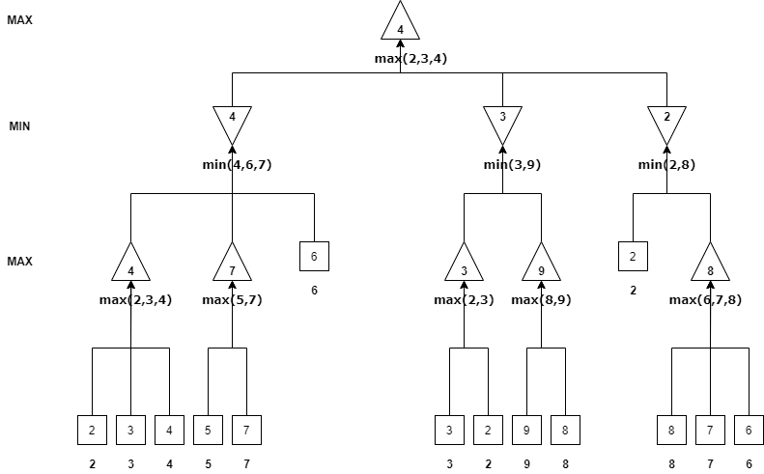

As we can see, MAX should take a1 as it has the biggest value.

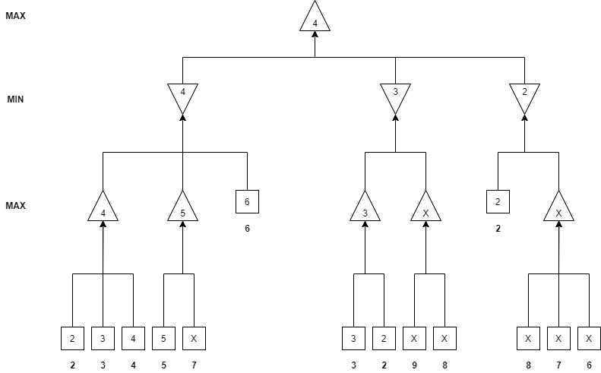

After doing Alpha-Beta-Search we also understand that MAX should take a1.

1. I would make this value to be at least 5. In that case this path’s value will range from 5 to 8 (depending on the value we choose for that node).